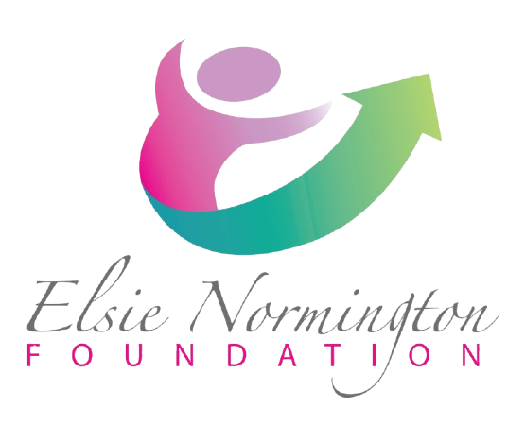
Role Description:
Café Manager
Location: Inverness, Highland
Salary: £28-32k
Hours: Full-time
Contract: Permanent
Line Manager: CEO
1. Introduction to the Elsie Normington Foundation
The Haven Café is a community café based at the Haven Centre in Smithton, operated by the Elsie Normington Foundation (ENF). The café is open to members of the public and all who use the centre. All profits generated contribute towards fulfilling the charitable aims of the Foundation and supporting future projects that benefit young people with disabilities and complex needs in the Highlands.
The Café Manager plays a key role in combining excellent hospitality with social impact, providing opportunities for young adults with additional support needs to gain experience, develop skills, and build confidence in a safe and supportive environment.
2. Role Overview
The Café Manager is responsible for the day-to-day supervision and operation of the Haven Café. They will lead and support a team of volunteers, including young adults with learning disabilities and additional support needs, providing tailored guidance and training to enable personal and professional development.
The Café Manager will report directly to the CEO and will be instrumental in developing the café as both a thriving community hub and a supportive training environment.
Key responsibilities include:
- Ensuring compliance with Food Safety, Environmental Health, and Health & Safety legislation, including safeguarding and risk management for young adults with additional support needs.
- Welcoming customers, delivering excellent service, and promoting the café locally and via ENF’s social media channels.
- Managing café opening and closing procedures, including use and maintenance of barista equipment.
- Supervising, mentoring, and training café volunteers, with an emphasis on supporting young adults with disabilities or additional support needs.
- Developing and maintaining café menus, including allergen and dietary information.
- Building and maintaining supplier relationships, managing orders, and overseeing deliveries.
- Operating the EPOS system, handling financial reconciliation, and ensuring accurate record keeping.
- Conducting monthly stock checks and maintaining equipment inventories.
- Overseeing cleaning schedules, COSHH procedures, and risk assessments to ensure a safe environment.
- Supporting food preparation and cooking as required, involving young adults in a safe and guided manner.
- Working with ENF Management and Trustees to develop the café, increase profitability, and explore opportunities such as external catering and supplier partnerships.
- Coordinating training and placement opportunities in the café for young adults with disabilities and complex needs.
- Implementing quality assurance processes to ensure high standards are maintained in all aspects of café operations.
3. Essential Requirements
- Knowledge of and compliance with Food Safety, Environmental Health, and Health & Safety regulations.
- Experience supervising, mentoring, and training young people with learning disabilities or additional support needs.
- Ability to operate a coffee machine and deliver high-quality barista service.
- Competency in using an EPOS till and handling financial reconciliation.
- Ability to develop menus with awareness of allergens and special dietary requirements.
- Strong organisational skills for stock management, inventory, and supplier liaison.
- Experience implementing cleaning schedules, COSHH procedures, and risk assessments.
- Excellent communication skills to work effectively with customers, volunteers, suppliers, and Trustees.
- Flexibility to assist with food preparation and cooking when required.
- Patience, empathy, and the ability to adapt tasks and training to individual abilities.

4. Desirable Requirements
- Experience working with young people with disabilities or complex needs.
- Experience in menu planning and catering for external events.
- Skills in budgeting, developing a business model, and maximising café profitability.
- Marketing and advertising experience, including use of social media to promote the café.
- Experience sourcing suppliers to improve quality and reduce costs.
- Commitment to continuous service improvement and volunteer development.
- Experience delivering accredited hospitality training or vocational programs.

